**Assignment no. 2 Reg no. 231701039**

**Aim:**

To develop and design a mobile or web applications to change background and menus .

**Procedure:**

1)Create the frame for the menu.

2)Enter the menu using text Box.

3)Align the text like menu.

4)Insert elements according to food theme and symbols too.

5)Atlast the output is obtained.

6)Save the design.

**Before:**

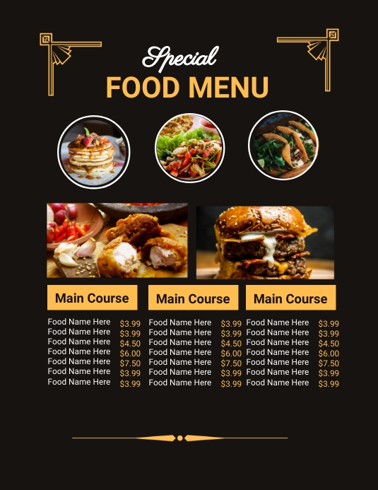

**After:**

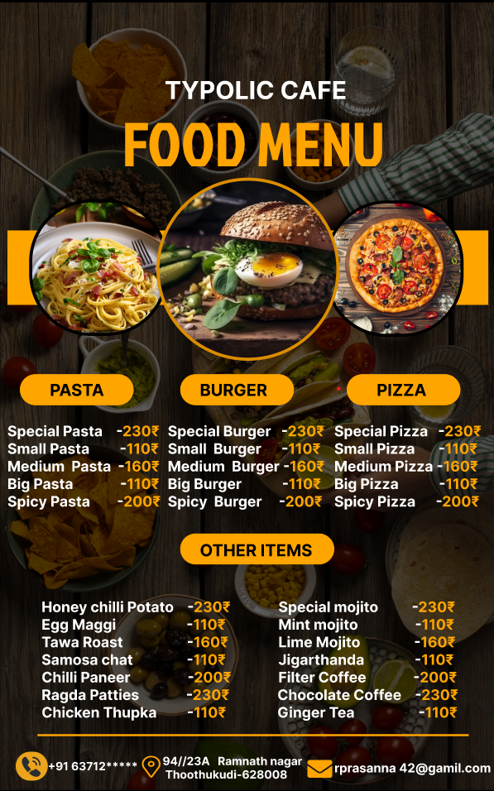

**Result:**

Thus the canteen menu is redesigned for ease of use and functionality.